TASK#01

- Running MAKE file to compile all the files mention in it.
- Using “Valgrind” to check the memory Leaks and detects the segmentation faults.
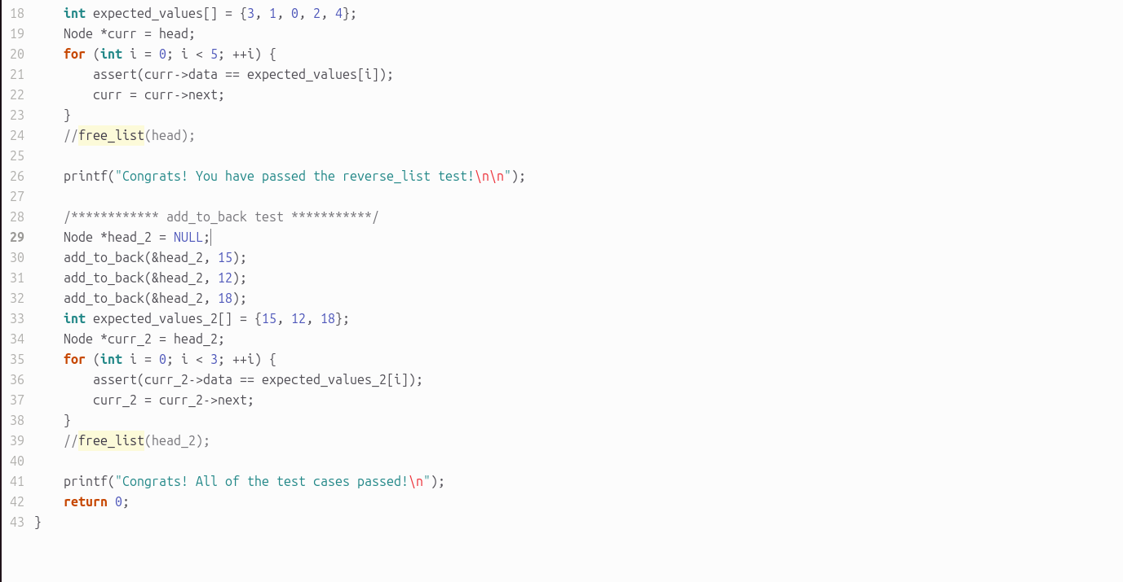
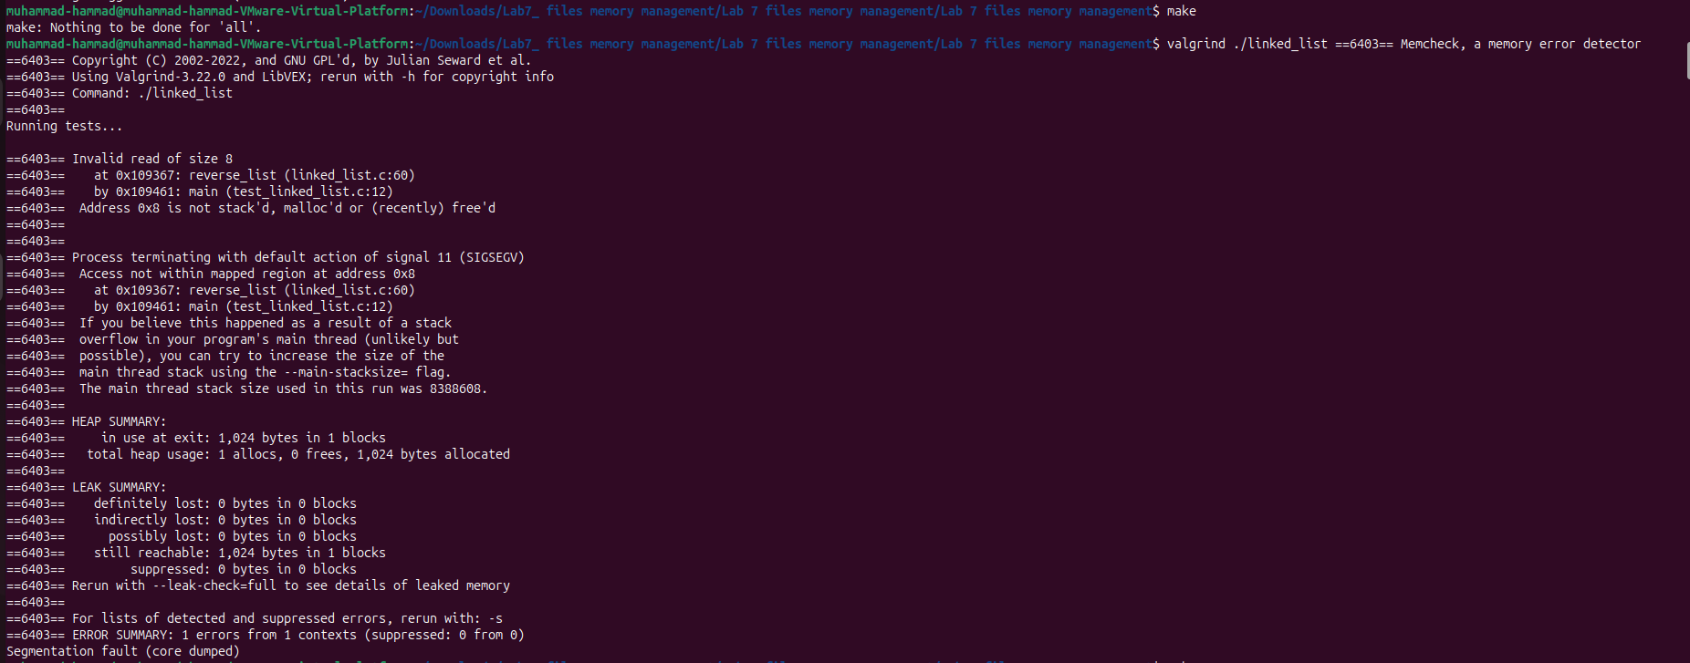
OUTPUT
- Comment out Free_list functions to create memory leaks and understand the working of “valgrind”.

TASK#02

- To find logical errors in the executable file “linked_list”, GDB is used.
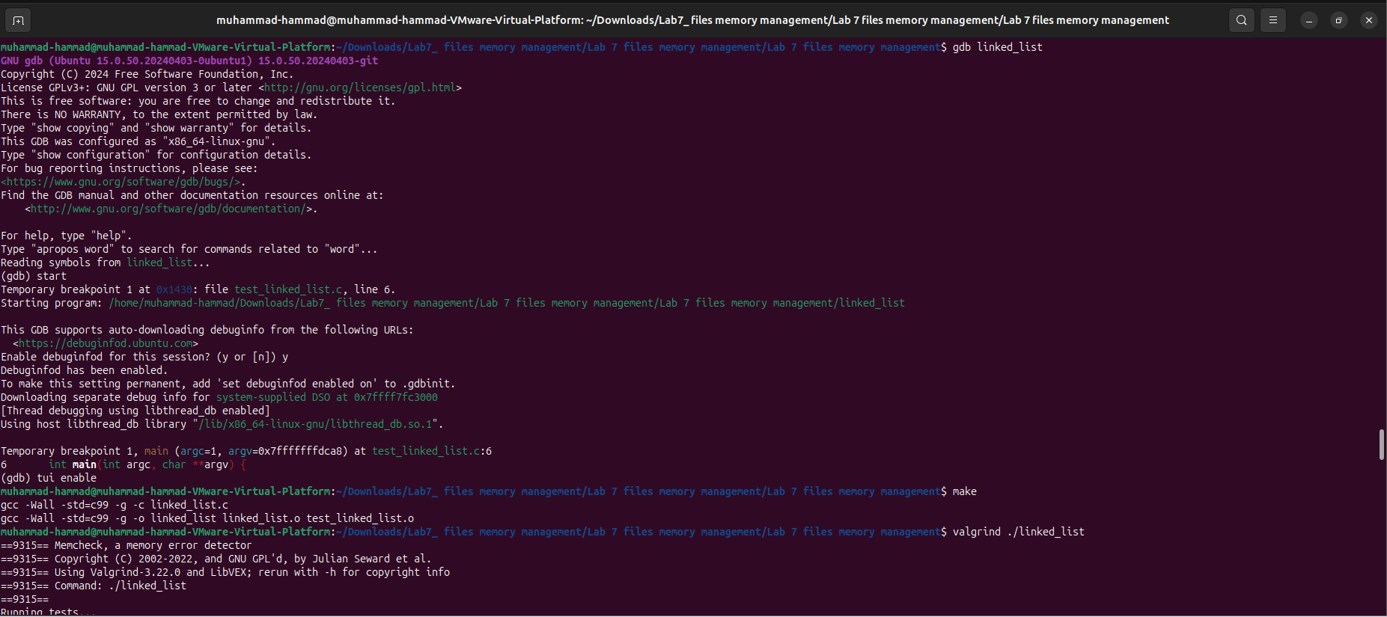
- Checks the errors and make changes in “linked_list.c”.
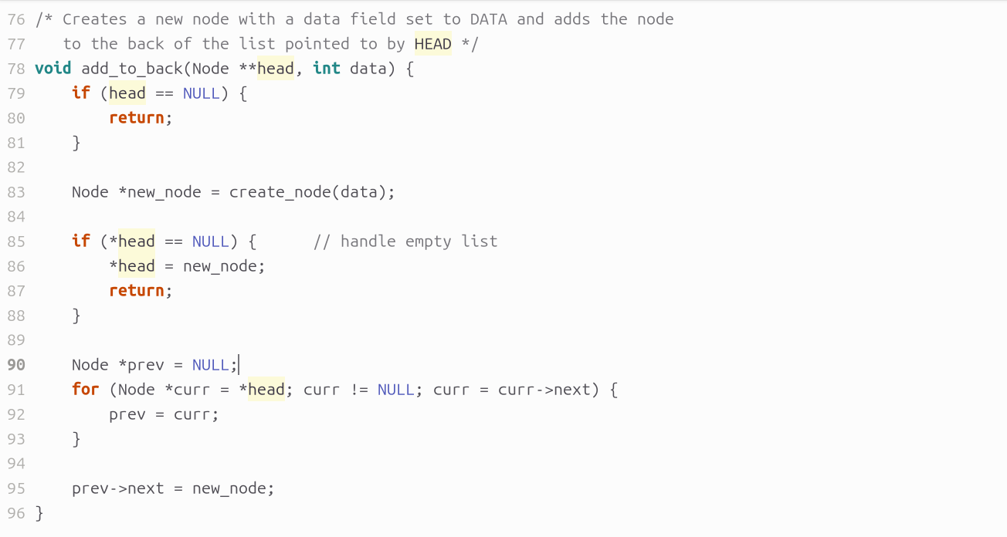
Make changes in “linked_list.c” to resolve the Segmentation Fault.

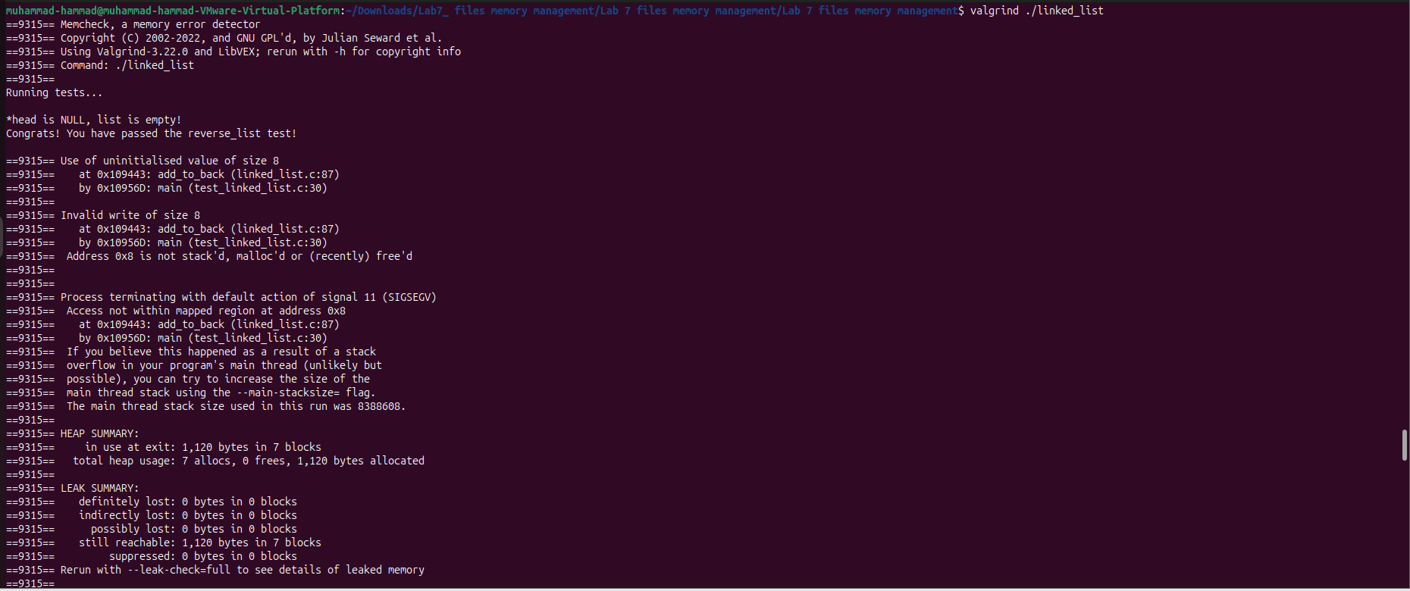
TASK#02: Reverse List Test Passed
Uncomment Free_List Functions to get the “Heap Memory” Freed up.

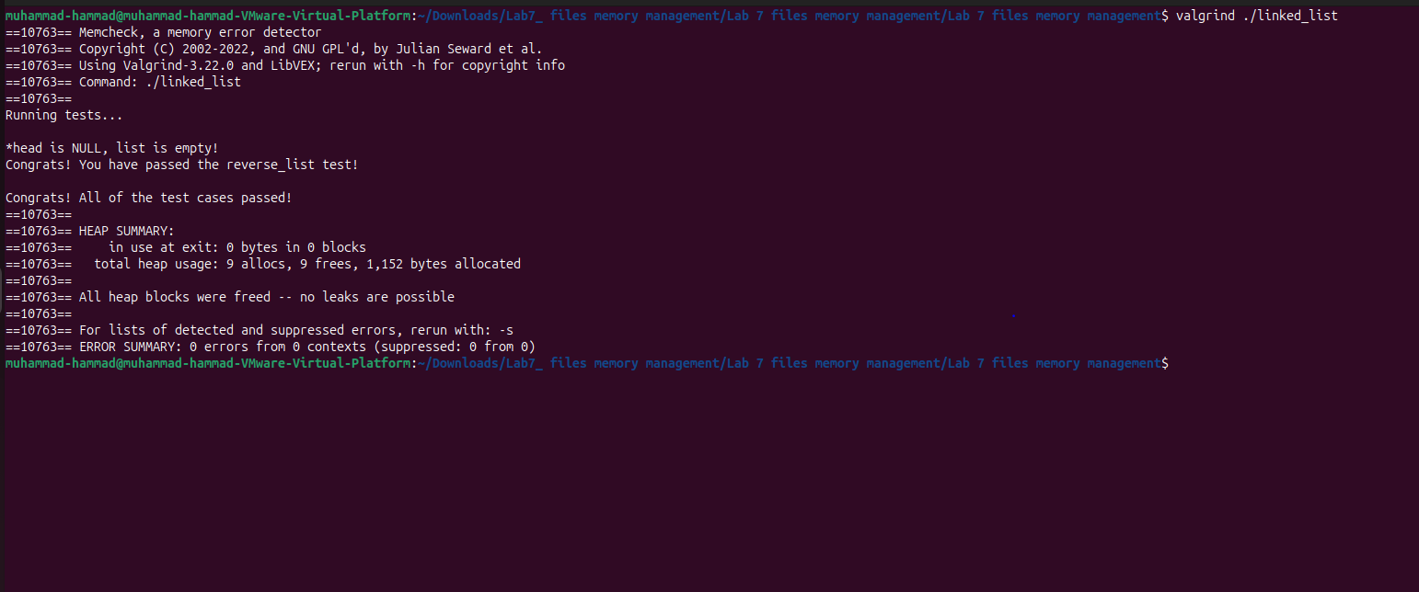
OUTPUT

TASK#03

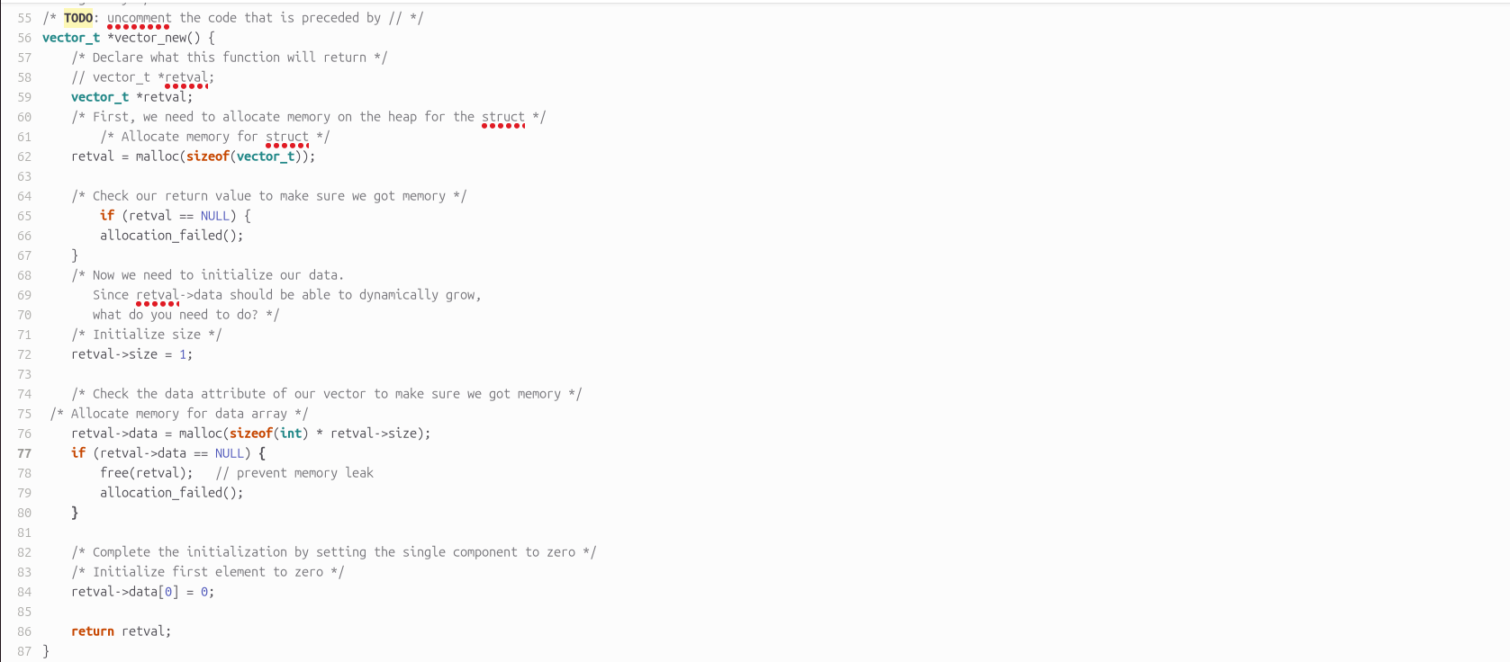
Writing Funtion for Vector_New

Writing Funtion for Vector_Get
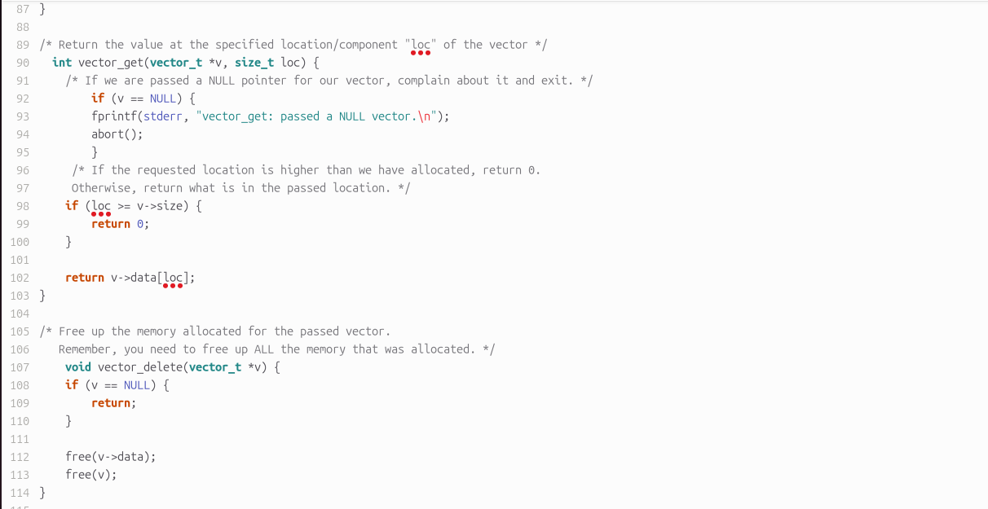

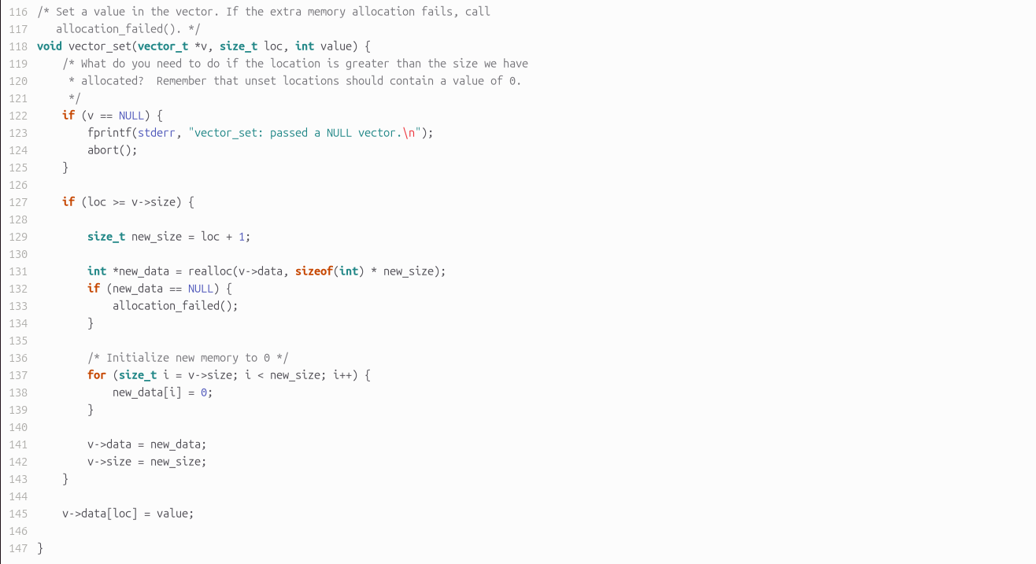
Writing Funtion for Vector_Set

OUTPUT

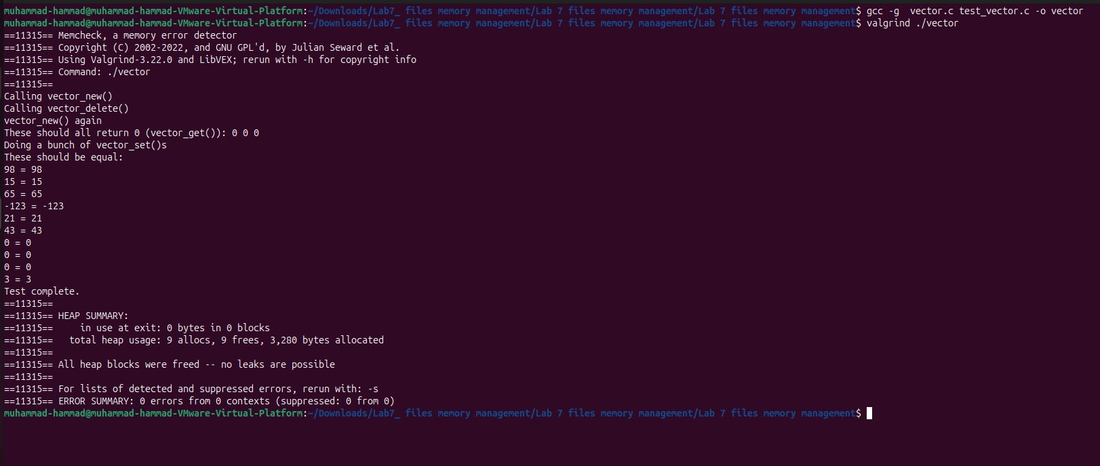

CONCLUSION:

• Learned proper dynamic memory allocation and deallocation using pointers and structs in C.
• Used Makefiles to efficiently compile and manage multi-file programs.
• Detected and fixed memory leaks and segmentation faults using Valgrind and cgdb.
• Successfully implemented a dynamic vector while ensuring safe and error-free memory management.

